Geometry Lab Project

To begin this project I first re-used the code from the original ray tracer project to give myself a starting point. I approached the design in the same manner, focusing on simplicity of the interface and ease of usability.

The user is initially presented with an axes and a blank background.

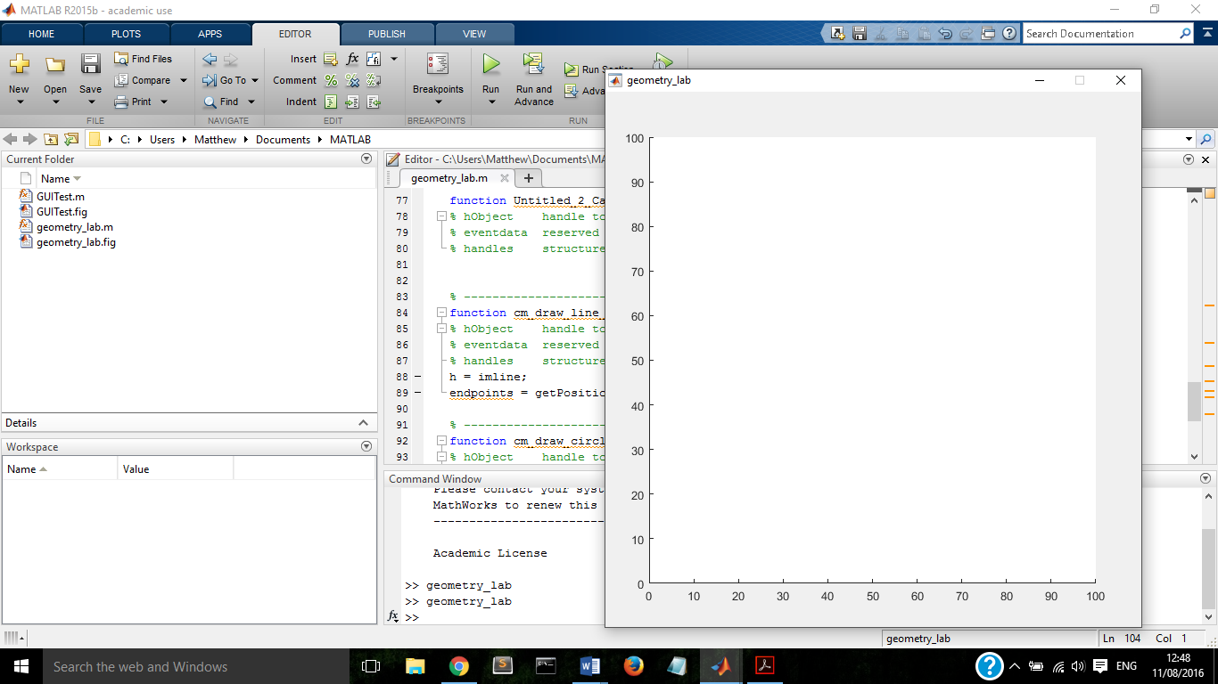

To add elements to the background, the user must right click anywhere in the whitespace and a drop down menu will appear, from here a line or a circle can be selected.

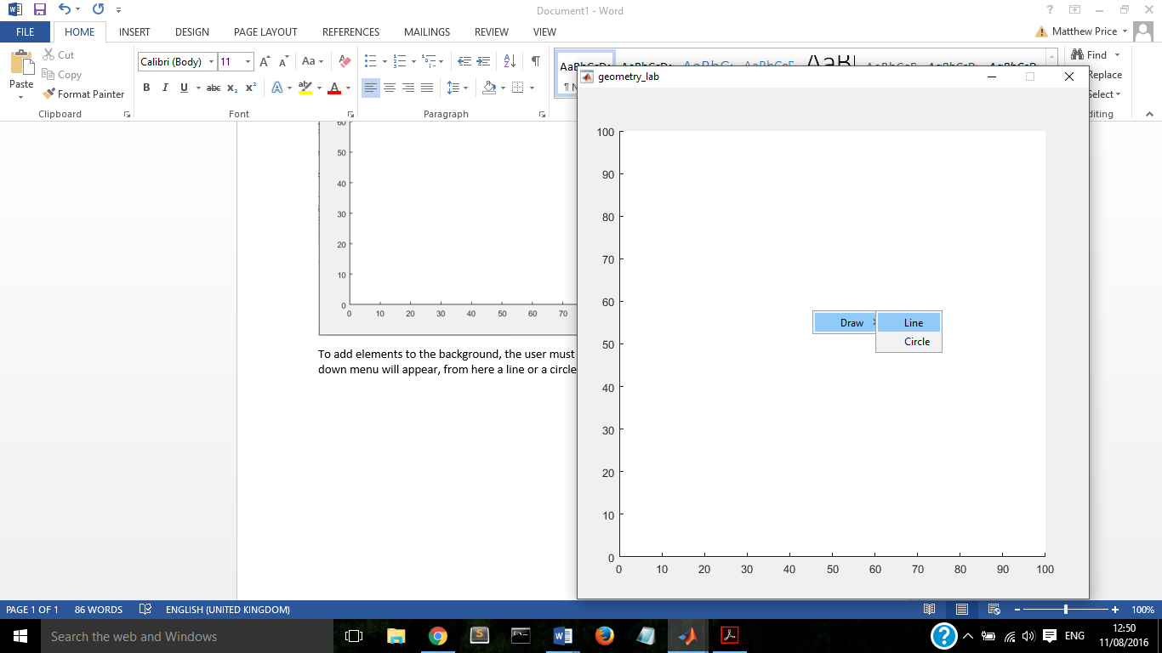

If a line is selected the cursor will change to a cross and the user can click and drag the mouse to draw a line between two points. Once drawn the line can be selected and moved, the endpoints become handles which can be dragged to alter the length and direction of the line.

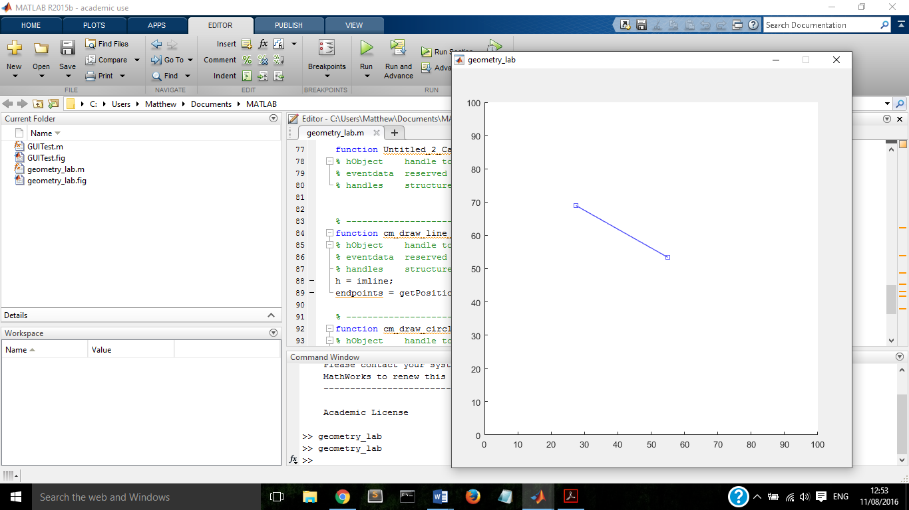

If a circle is selected a small circle will appear in the lower left part of the window, this circle can then be dragged or resized in a similar manner to the line, the circle must be generated and not freely drawn in order to force a perfect circular shape and not an ellipse.

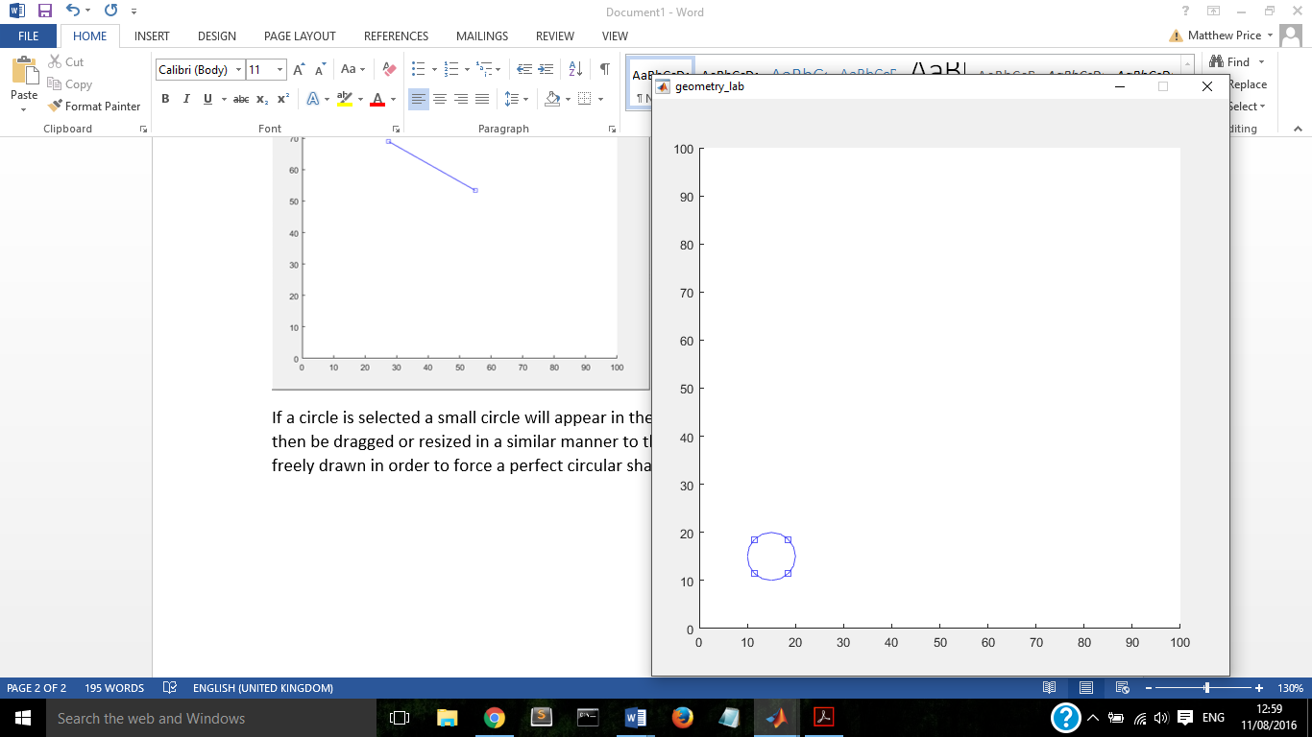

Elements can be removed by right clicking them and selecting delete from the drop down list.

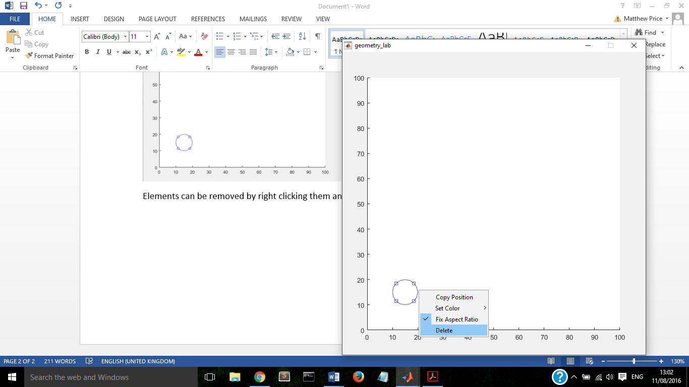

The user can draw as many lines and circles in the environment as they wish.

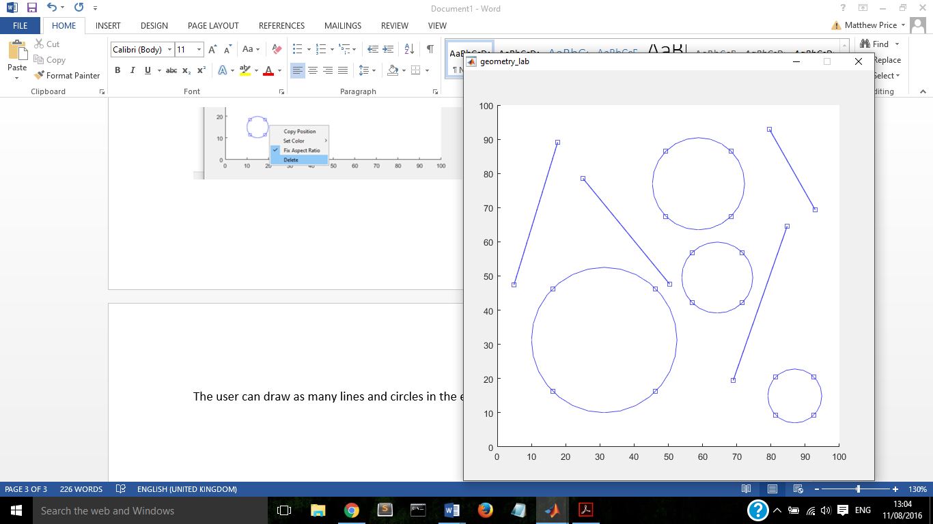

This is as far as I managed to get in terms of matlab implementation, I will now provide a worked example of how to find the point of intersection between these shapes.

First an example of two crossed lines.

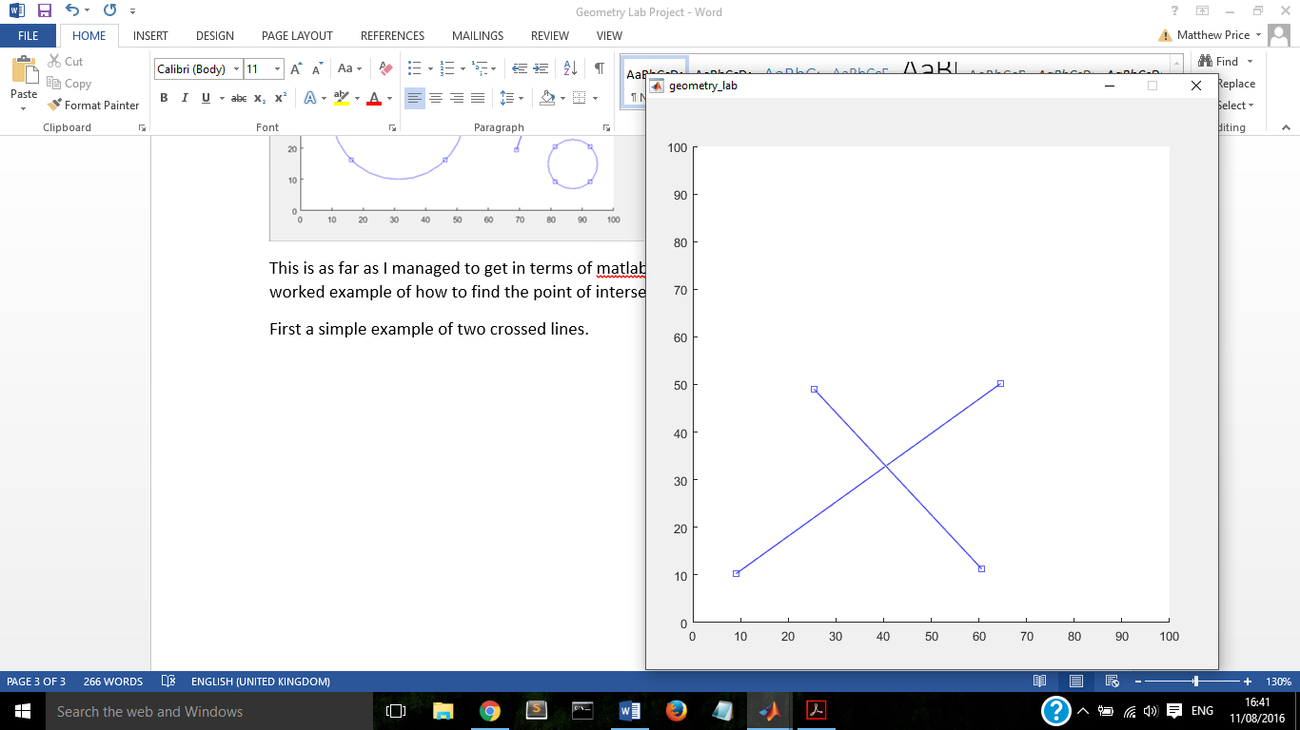

By right clicking each line I can select ‘copy position’ from the drop down list and obtain a set of coordinates in the form,.

Line 1: [9.08183632734531 10.2794411177645; 64.5708582834331 50.1996007984032]

Line 2: [60.5788423153693 11.2774451097805; 25.4491017964072 49.0019960079841]

We must first find the gradient of each line, this is done using the following equation.

Line 1:

Line 2:

Now we have the gradients we can find the intercept for each line in the form.

Line 1:

And convert this to the form,

Line 2:

And converting once more

Now to determine the coordinates of the point of intersection these equations must be solved simultaneously.

Line 1:

Line 2:

Adding these two equations together will eliminate the y term and leaves us with

And to obtain the y coordinate we substitute our new value of x into either original equation

Therefore our coordinates at the point of intersection are



Through my research I found that this should have been achievable using the r8matsolve function in matlab, however I was only able to get this to show me an answer of 1, indicating that the lines intersect and not the coordinates of said intersection.

Next I will give an example of intersection between a line and a circle.

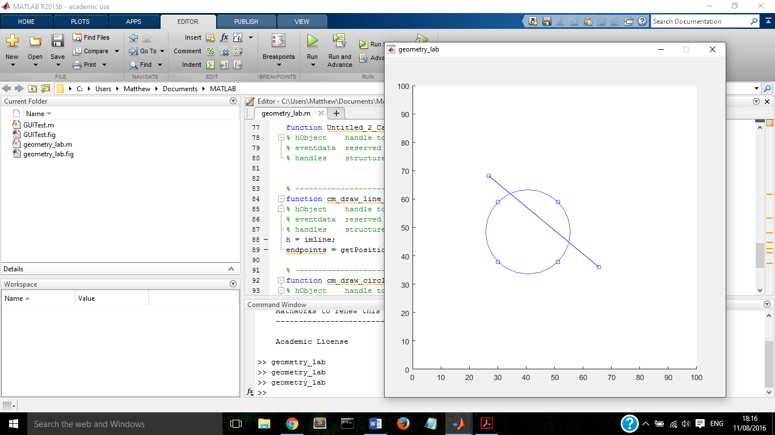

By clicking ‘copy position’ on the circle I obtained the following coordinates

[25.7684630738523 33.5528942115768 29.7604790419162 29.7604790419162]

These represent the min, min, height and width respectively. The min is the leftmost part of the circle, the min is the lowest part, and the height and width are identical (as you would expect from a circle) and therefore denote the diameter. To put this into an equation we must first obtain the coordinates of the centre, this is achieved by adding the radius (half the diameter) to the min values. Giving us

We also have

The equation of a circle is where [h,k] are the coordinates of the centre

So our circle has equation

Next we must find the equation of the line, the lines coordinates are

[26.8463073852295 68.1636726546906; 65.5688622754491 36.0279441117765]

(

Line: (

Substituting line equation into circle equation gives us

Expanding the brackets yields

And simplifying gives

Now to use the quadratic formula

To check that the lines intersect and how many pairs of coordinates we are expecting we use the discriminant, this is the part of the equation, an answer greater than 0 indicates 2 real roots i.e. a line that intersects the circle twice (secant). Exactly 0 indicates 1 real root or a tangent, and an answer below 0 indicates 2 complex roots.

So we are expecting two pairs of co ordinates

Subbing these values into the original line equation gives us

So our final coordinates are [55.06, 44.75; 35.37, 61.92]

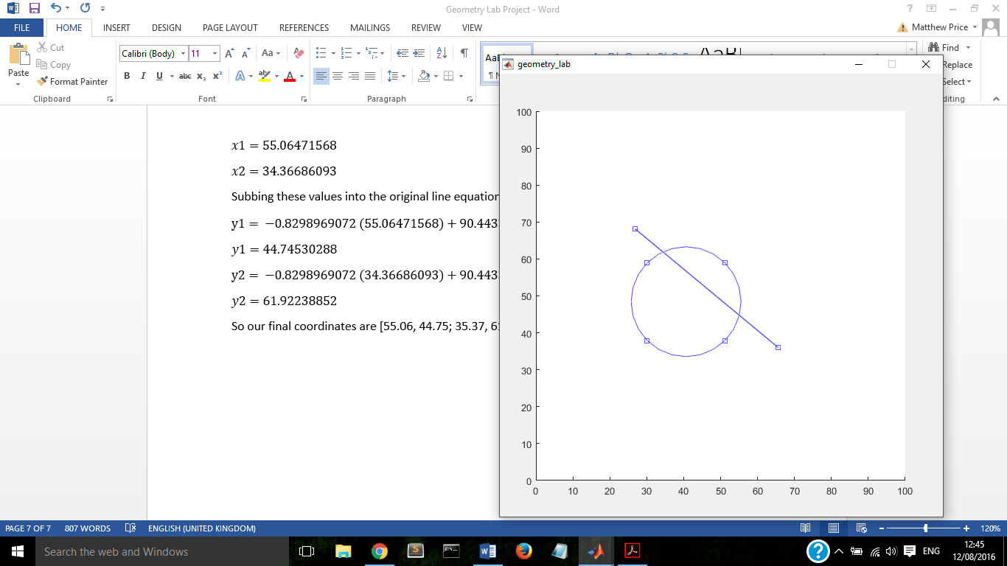

Finally I will demonstrate how to find the points of intersection between two circles.

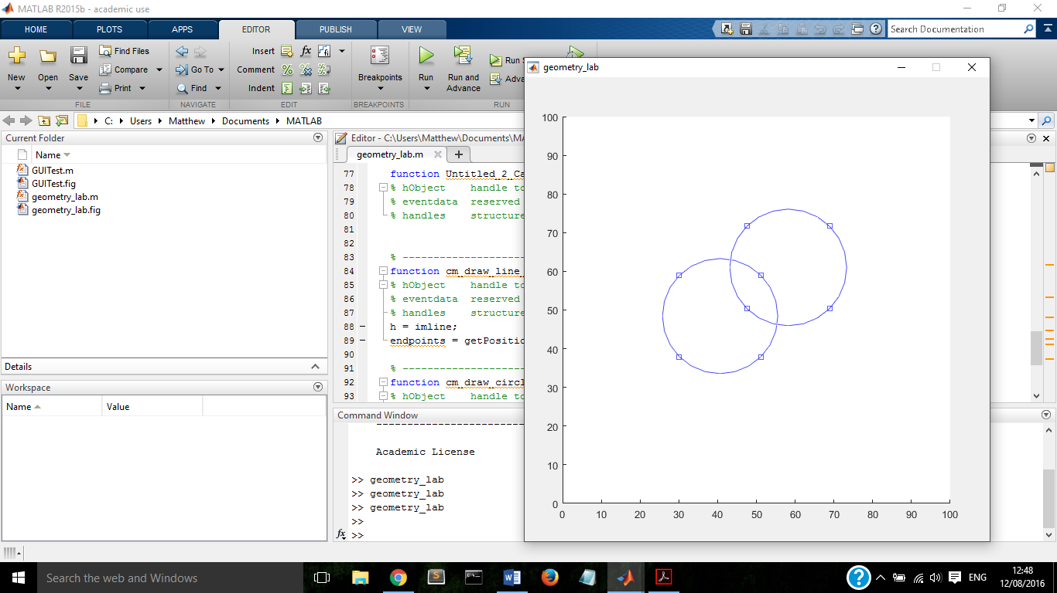

The leftmost circle is the same as the previous example so we already know its equation

The dimensions of the second circle are as follows

[43.1337325349301 45.9281437125748 30.1596806387225 30.1596806387225]

To find the points of intersection I will use a set of formulae obtained from <http://www.calcul.com/circle-circle-intersection?x01=58.21357285&y01=61.00798403&r1=15.07984032&x02=40.64870259&y02=48.43313373&r2=14.88023952&op=Calculate&form_build_id=form-b5162f8076d8b2dfdaeecdf9c2e3277e&form_id=calc_main_form>

So our intersection points are at [43.28, 63.08; 55.36, 46.20]

